**5.1 Business Requirements:**

This system is a platform for event organizers to do business. They can advertise their events on this website to attract the people. When any person click on the attend button they need to fill the required form attending the event. Event Organizers can organize events according to the demand. For Example, suppose in some areas people are fond of sports activities then the event organizers can organize sports events in those areas to attract people. The best services the event organizers give the more users will attract.

**5.2 Process Flow:**

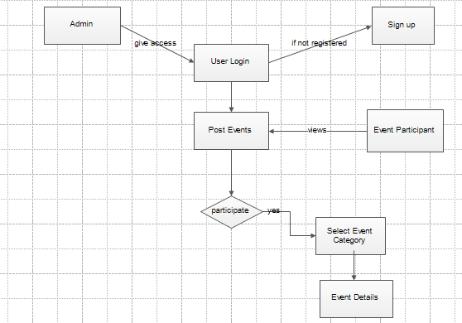

**Figure 5: Process Flow**

**5.3 Functional Requirements:**

# FR01: Event Organizers/ Advertisers Login

|  |  |
| --- | --- |
| FR01-01 | System shall allow event organizer/advertiser to login. |
| FR01-02 | System shall get Username from event organizer. |
| FR01-03 | System shall get password from event organizer. |
| FR01-04 | System shall allow event organizer to remember his username and password by entering into the checkbox. |

**Table 01: Event Organizer Login**

**FR02: Sign up for Unregistered Event Organizers**

|  |  |
| --- | --- |
| FR02-01 | System shall allow unregistered event organizers to sign up for posting an event. |
| FR02-02 | System shall allow event organizers to fill all required fields for signing. |
| FR02-03 | System shall validate registration from data. |

**Table 02: Event Organizer Signup**

**FR03: View Events**

|  |  |
| --- | --- |
| FR03-01 | System shall allow users/participants to select event category. |
| FR03-02 | System shall allow users/participants to view the event he has selected. |
| FR03-03 | System shall allow users/participants to view event venue. |
| FR03-04 | System shall allow users/participants to view event date and time. |

**Table 03: View Events**

**FR04: Search Events**

|  |  |
| --- | --- |
| FR04-01 | System shall allow users to search events in their area. |
| FR04-02 | Users can search the event by writing keyword in the search text box. |

**Table 04: Search Events**

**FR05: User’s Participation**

|  |  |
| --- | --- |
| FR05-01 | Event Organizers shall allow users to participate in the upcoming events. |
| FR05-02 | To participate in the event, users must select the event category or location. |
| FR05-03 | Users can participate in the event by clicking on the attend button. |
| FR05-04 | Users must fill required information on clicking the attend button. |

**Table 05: User Participation**

**FR06: Post Events**

|  |  |
| --- | --- |
| FR06-01 | System shall allow event organizers to select event category in which they can post event. |
| FR06-02 | System shall allow event organizers to post an event. |
| FR06-03 | System shall allow event organizer to give venue of the event. |
| FR06-04 | System shall allow event organizer to give date and time of the event. |

**Table 06: Post Events**

**FR07: Edit Events**

|  |  |
| --- | --- |
| FR07-01 | System shall allow event organizers to edit the events which they have posted. |
| FR07-02 | System shall allow event organizers to change the venue of the event. |
| FR07-03 | System shall allow event organizer to change date of the event. |
| FR07-04 | System shall allow event organizer to change time of the event. |
| FR07-05 | System shall allow event organizer to change events category. |

**Table 07: Edit Events**

**FR08: Delete Events**

|  |  |
| --- | --- |
| FR08-01 | Admin can delete the events if the event’s day is passed. |

**Table 08: Delete Events**

**FR-09: Log out of the system**

|  |  |
| --- | --- |
| FR9-01 | System shall allow users to log out. |

**Table 09: Logout**

**5.4 Non Functional Requirements:**

## NFR01: Performance

|  |  |
| --- | --- |
| NFR01-01 | The Average load time of the starting page of the system must be less than 5 seconds. |
| NFR01-02 | System must successfully run on a client machine with 512 MB RAM or above. |
| NFR01-03 | Multiple Event Organizers can post their events on the website at the same time. |
| NFR01-04 | Average system response time should not be greater than 5 seconds. |

**Table 10: Performance**

## NFR02: Security

|  |  |
| --- | --- |
| NFR02-01 | System must provide access to only registered event organizers for posting events. |
| NFR02-02 | System must not provide access to event organizers to edit the events of other event organizers. |
| NFR02-03 | An event participant is not allowed to see any personal information of any event organizer. |

**Table 11: Security**

## NFR03: Availability

|  |  |
| --- | --- |
| NFR03-01 | This web based application shall be available 24 hours a day. |
| NFR03-02 | User may access it from any part of the world. |

**Table 12: Availability**

## NFR04: Usability

|  |  |
| --- | --- |
| NFR04-01 | The system should be easy to use for any user. |
| NFR04-02 | Time to learn overall interface of the system should be minimal. |

**Table 13: Usability**

## NFR05: Readability

|  |  |
| --- | --- |
| NFR05-01 | There should not be any missing information for past and upcoming events. |
| NFR05-02 | There should not be any bad coloring scheme which creates difficulties for users to understand it. |
| NFR05-03 | Font size should be normal so that it can be easily readable. |

**Table 14: Readability**

# 5.5 Actors:

Following is a list of actors and their responsibilities:

## 5.5.1 Admin:

The admin manages all the accounts of event organizer and configuration related to the system. The admin has full access to the system and ensures all the Data Management and security issues related to the system.

**Responsibilities:**

* Allow Event Organizer to post an event.
* Manage all events posted by event organizers.
* Displayed events for participants.
* Delete account of an event organizer.
* Can delete events.

## 5.5.2 Event Organizer:

Event Organizer is the person who will use the system to manage all participants. The system will give full access to the event organizers to manage participants who want to attend their event.

**Responsibilities:**

* Log in to the system
* Select event category
* Select event location
* Post an event
* Edit events information
* Change event venue
* Change event date and time
* Log out from the system

## 5.5.3 Event Participant:

Event Participant is the user who will use the system to get information about the events.

**Responsibilities:**

* Select Location
* View events
* Participate in the event

# 5.6 Use Cases:

Following are the list of use cases:

1. Login
2. Sign up
3. Locate/Search events
4. View events
5. Attending events
6. Post events
7. Edit events
8. Delete events
9. Log out

## 4.6.1 UC-01: Login

#### **Brief Description:**

This use case defines the Event Organizer Login process by which event organizer shall be log into the system according to the privileges assigned.

#### **Actors:** Admin, Event Organizer

#### **Pre-condition(s):**

1. Event Organizer must have an account for login

#### **Main Flow:**

1. Use case starts when Event Organizer or Administrator accesses the system through its web address (URL).
2. The system displays a screen for login.
3. Event Organizer shall enter Username and Password on login screen.
4. User shall tick the ‘Remember Me’ checkbox
5. User shall press Submit button.
6. System shall authenticate the user and give privileges according to user type.
7. The system takes the user to home page.
8. Use case ends with the successful login of the user.

#### **Alternative Flows:**

5a) User clears Username and Password by clicking ‘Reset’ Button

6a) System prompts the user for missing username and password

6b) If log information is not authenticated, system prompts the user for correct and valid login information

#### **Post-condition(s):**

Event Organizer is logged in to the system and can use the system as the privileges assigned to that event organizer and is redirected to home page.

## 5.6.2 UC-02: Signup

#### **Brief Description:**

This use case defines the sign up process for the event organizers who are not registered.

**Actors:** Event Organizer

#### **Pre-condition(s):**

1. Event Organizer is not a registered member.

#### **Main Flow:**

1. Event Organizer selects signup link from login screen.
2. System displays sign up form.
3. Event Organizer enters the form data correctly.
4. Event Organizer clicks the “submit” button after completion of the form.
5. System validates registration form data.
6. The system prepared a query to enter the new member’s registration data into the database.
7. The system prompts successful registration message after successful database query execution.

#### **Alternative Flows:**

2a) User enters incorrect data in the registration from/ leaves mandatory field empty.

2b) User clicks the “submit” button after completion of the form.

2c) System detects incorrect/inconsistent data in the form and will prompt an error message.

#### **Post-condition(s):**

The Event Organizer becomes a registered member.

## 5.6.3 UC-03: Search Events

#### **Brief Description:**

This use case defines location of events posted by event organizers. Users can search events in their respective areas.

**Actors:** Event Participant

#### **Pre-condition(s):**

1. There must be list of events posted on the website.

#### **Main Flow:**

1. Event participant must give the proper URL of website.
2. Event Participant must give the location in the search textbox.
3. Event Participant must click on the search button.
4. Event Participant can get the information about events in his respective location.

#### **Alternative Flows:**

3a) Event Participant clicks the search button without typing in the search textbox.

3b) System shows the error message.

#### **Post-condition(s):**

Event Participant successfully searches the events.

## 5.6.4 UC-04: View Events

#### **Brief Description:**

This use case defines the information of all events on the main page of website.

**Actors:** Event Participant, Admin

#### **Pre-condition(s):**

1. There must be categories of events listed.

#### **Main Flow:**

1. Event participant must give the proper URL of website.
2. Event Participant must select the event category.
3. System displays all the events of that category.
4. Event Participant must select the event.
5. Event Participant must click on the the view button to get all the information of the event.

#### **Post-condition(s):**

Event Participant successfully views all the events.

## 5.6.5 UC-05: Attending Events

#### **Brief Description:**

This use case defines participating process in which users participates in the events.

**Actors:** Event Participant, Event Organizer

#### **Pre-condition(s):**

1. The system must contain information about selected event.
2. System functions properly

#### **Main Flow:**

1. Event participant must select the event category.
2. Event participant must select events in which he wants to participate.
3. Event participant must click the attend button to participate.
4. Event participant must fill the necessary information to participate.

#### **Alternative Flows:**

4a) Event Participant leaves the fields empty and click on the submit button.

4b) System displays error message.

#### **Post-condition(s):**

Event Participant successfully registered for participating.

## 5.6.6 UC-06: Post Events

#### **Brief Description:**

This use case defines the process of posting an event on the website.

**Actors:** Event Organizer

#### **Pre-condition(s):**

1. Event Organizer is logged in.
2. Admin enters correct information in all forms

#### **Main Flow:**

1. Event organizer must click on the “Post an event” hyperlink.
2. System displays an event entry form to the event organizer.
3. Event organizer fills in the form correctly and clicks on the “submit” button.
4. System validates the form.
5. System prompts successful registered message.

#### **Post-condition(s):**

New events have been added into the system.

**5.7 Use Case Diagrams:**

**5.7.1 UC01: Login**

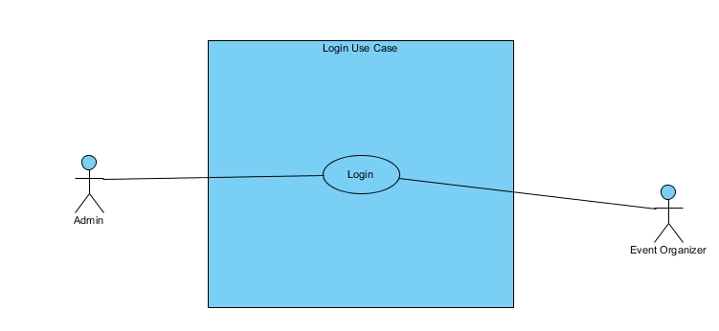

**Figure 5: Use Case Login**

**5.7.2 UC02: Sign up**



**Figure 6: Use Case Signup**

**5.7.3 UC03: Post Events**

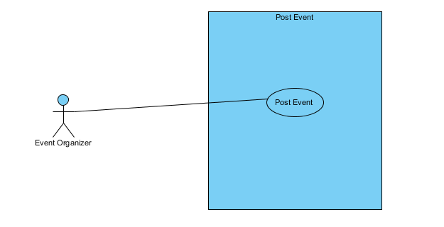

**Figure 7: Use Case Post Events**

**5.7.4 UC04: Edit Events**

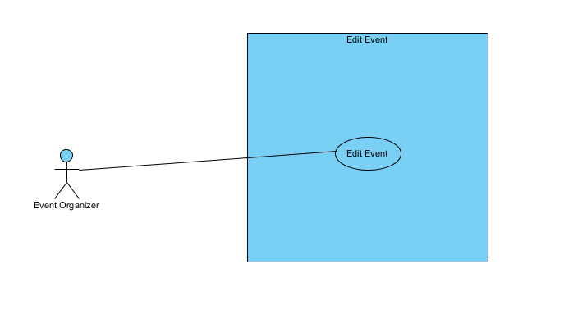

**Figure 8: Use Case Edit Events**

**5.7.5 UC05: View Events**

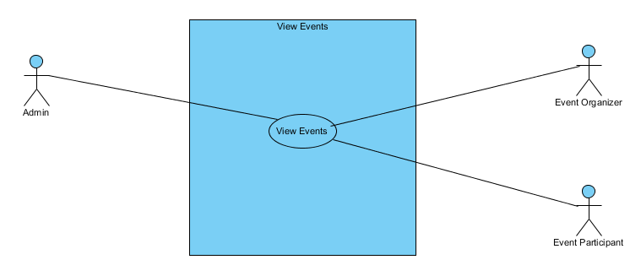

**Figure 9: Use Case View Events**

**5.7.6 UC06: Search Events**

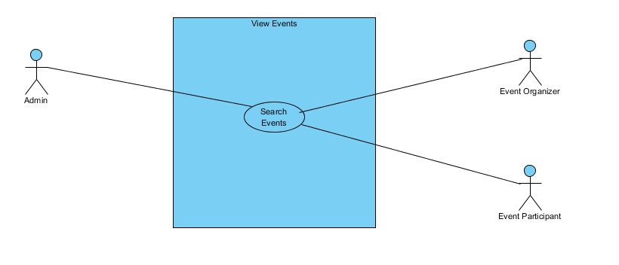

**Figure 10: Use Case Search Events**

**5.7.7 UC07: Attending Events**

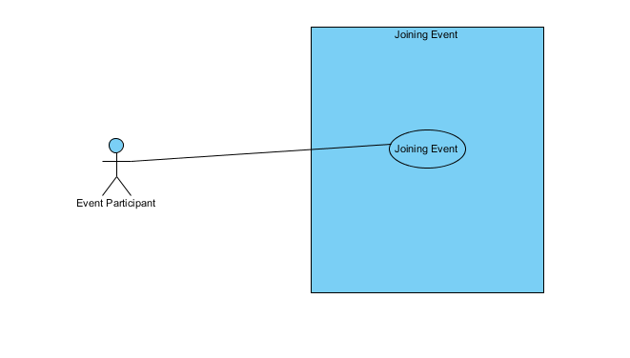**Figure 11: Use Case Join Events**

**4.7.8 UC08: Delete Events**

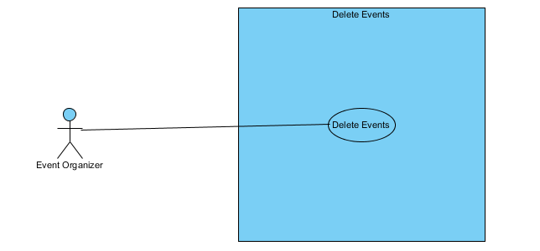

**Figure 12: Use Case Delete Events**

**5.7.9 UC09: Log out**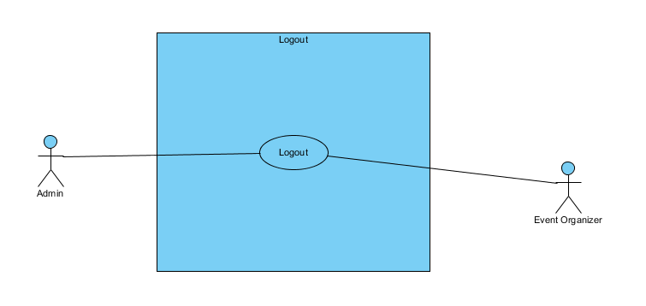

**Figure 13: Use Case Log out**

**Use Case Diagram of Whole System:**

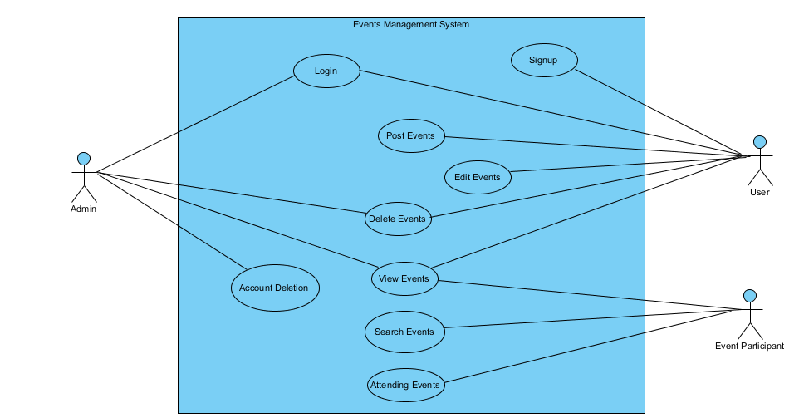

**Figure 14: Use Case Log out**

**5.8 Traceability Matrix:**

# *Table 15: Traceability Matrix*

# *FR01: Event Organizers/ Advertisers Login*

|  |  |  |  |  |
| --- | --- | --- | --- | --- |
| **Req. No.** | **Actor** | **Functional Requirements** | **UC#** | **Non-Functional Requirements** |
| FR01-01 | Event Organizer | System shall allow event organizer/advertiser to login. | UC01 | NFR01-01  NFR01-04  NFR02-01  NFR02-03 |
| FR01-02 | Event Organizer | System shall get Username from event organizer. | UC01 | NFR01-01  NFR01-04  NFR02-01  NFR02-03 |
| FR01-03 | Event Organizer | System shall get password from event organizer. | UC01 | NFR01-01  NFR01-04  NFR02-01  NFR02-03 |
| FR01-04 | Event Organizer | System shall allow event organizer to remember his username and password by entering into the checkbox. | UC01 | NFR01-01  NFR01-04  NFR02-01  NFR02-03 |

***FR02: Sign up for Unregistered Event Organizers***

|  |  |  |  |  |
| --- | --- | --- | --- | --- |
| **Req. No.** | **Actor** | **Functional Requirements** | **UC#** | **Non-Functional Requirements** |
| FR02-01 | Event Organizer | System shall allow unregistered event organizers to sign up for posting an event. | UC02 | NFR01-01  NFR01-04  NFR02-01 |
| FR02-02 | Event Organizer | System shall allow event organizers to fill all required fields for signing. | UC02 | NFR01-01  NFR01-04  NFR02-01 |
| FR02-03 | Event Organizer | System shall validate registration from data. | UC02 | NFR01-01  NFR01-04  NFR02-01 |

***FR03: View Events***

|  |  |  |  |  |
| --- | --- | --- | --- | --- |
| **Req. No.** | **Actor** | **Functional Requirements** | **UC#** | **Non-Functional Requirements** |
| FR03-01 | Event Participant | System shall allow users/participants to select event category. | UC04 | NFR01-01  NFR01-02  NFR01-04  NFR03-01  NFR03-02  NFR04-01  NFR05-01  NFR05-02  NFR05-03 |
| FR03-02 | Event Participant | System shall allow users/participants to view the event he has selected. | UC04 | NFR01-01  NFR01-02  NFR01-04  NFR03-01  NFR03-02  NFR04-01  NFR05-01  NFR05-02  NFR05-03 |
| FR03-03 | Event Participant | System shall allow users/participants to view event venue. | UC04 | NFR01-01  NFR01-02  NFR01-04  NFR03-01  NFR03-02  NFR04-01  NFR05-01  NFR05-02  NFR05-03 |
| FR03-04 | Event Participant | System shall allow users/participants to view event date and time. | UC04 | NFR01-01  NFR01-02  NFR01-04  NFR03-01  NFR03-02  NFR04-01  NFR05-01  NFR05-02  NFR05-03 |

***FR04: Search Events***

|  |  |  |  |  |
| --- | --- | --- | --- | --- |
| **Req. No.** | **Actor** | **Functional Requirements** | **UC#** | **Non-Functional Requirements** |
| FR04-01 | Event Participant | System shall allow users to search events in their area. | UC03 | NFR01-01  NFR01-02  NFR01-04  NFR03-01  NFR03-02  NFR04-01  NFR04-02  NFR05-02  NFR05-03 |
| FR04-02 | Event Participant | Users can search the event’s location by clicking on the search button. | UC04 | NFR01-01  NFR01-02  NFR01-04  NFR03-01  NFR03-02  NFR04-01  NFR04-02  NFR05-02  NFR05-03 |

***FR05: User’s Participation***

|  |  |  |  |  |
| --- | --- | --- | --- | --- |
| **Req. No.** | **Actor** | **Functional Requirements** | **UC#** | **Non-Functional Requirements** |
| FR05-01 | Event Organizer | Event Organizers shall allow users to participate in the upcoming events. | UC05 | NFR03-01  NFR03-02  NFR04-01  NFR05-01 |
| FR05-02 | Event Participant | To participate in the event, user must select the event category. | UC05 | NFR03-01  NFR03-02  NFR04-01  NFR05-01 |
| FR05-03 | Event Participant | Participants can participate in the event by clicking on the attend button. | UC05 | NFR03-01  NFR03-02  NFR04-01  NFR05-01 |
| FR05-04 | Event Participant | Participants must fill required information on clicking the attend button. | UC05 | NFR03-01  NFR03-02  NFR04-01  NFR05-01 |

***FR06: Post Events***

|  |  |  |  |  |
| --- | --- | --- | --- | --- |
| **Req. No.** | **Actor** | **Functional Requirements** | **UC#** | **Non-Functional Requirements** |
| FR06-01 | Event Organizer | System shall allow event organizers to select event category in which they can post event. | UC01 UC06 | NFR01-01  NFR01-03  NFR02-01  NFR02-02  NFR02-03 |
| FR06-02 | Event Organizer | System shall allow event organizers to post an event. | UC01  UC06 | NFR01-01  NFR01-03  NFR02-01  NFR02-02  NFR02-03 |
| FR06-03 | Event Organizer | System shall allow event organizer to give venue of the event. | UC06 | NFR01-01  NFR01-03  NFR02-01  NFR02-02  NFR02-03 |
| FR06-04 | Event Organizer | System shall allow event organizer to give date and time of the event. | UC06 | NFR01-01  NFR01-03  NFR02-01  NFR02-02  NFR02-03 |
| FR06-05 | Event Organizer | System shall allow event organizer to add new event category if it is not listed in the website. | UC01  UC06 | NFR01-01  NFR01-03  NFR02-01  NFR02-02  NFR02-03 |

***FR07: Edit Events***

|  |  |  |  |  |
| --- | --- | --- | --- | --- |
| **Req. No.** | **Actor** | **Functional Requirements** | **UC#** | **Non-Functional Requirements** |
| FR07-01 | Event Organizer | System shall allow event organizers to edit the events which they have posted. | UC01  UC07 | NFR01-01  NFR01-03  NFR02-01  NFR02-02  NFR02-03 |
| FR07-02 | Event Organizer | System shall allow event organizers to change the venue of the event. | UC07 | NFR01-01  NFR01-03  NFR02-01  NFR02-02  NFR02-03 |
| FR07-03 | Event Organizer | System shall allow event organizer to change date of the event. | UC07 | NFR01-01  NFR01-03  NFR02-01  NFR02-02  NFR02-03 |
| FR07-04 | Event Organizer | System shall allow event organizer to change time of the event. | UC07 | NFR01-01  NFR01-03  NFR02-01  NFR02-02  NFR02-03 |
| FR07-05 | Event Organizer | System shall allow event organizer to change events category. | UC01  UC07 | NFR01-01  NFR01-03  NFR02-01  NFR02-02  NFR02-03 |

***FR08: Delete Events***

|  |  |  |  |  |
| --- | --- | --- | --- | --- |
| **Req. No.** | **Actor** | **Functional Requirements** | **UC#** | **Non-Functional Requirements** |
| FR08-01 | Event Organizer | System shall allow event organizers to delete the events. | UC01  UC08 | NFR01-01  NFR01-04  NFR02-02 |

***FR09: Log out of the System***

|  |  |  |  |  |
| --- | --- | --- | --- | --- |
| **Req. No.** | **Actor** | **Functional Requirements** | **UC#** | **Non-Functional Requirements** |
| FR09-01 | Event Organizer | System shall allow event organizer to log out. | UC10 | NFR01-01  NFR01-04  NFR03-01 |

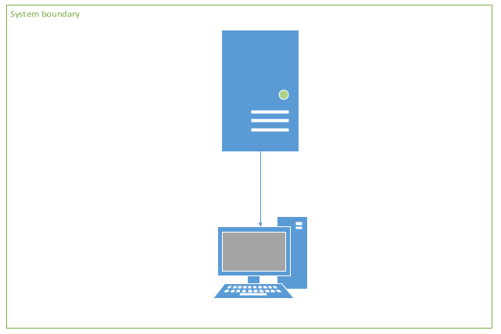**5.9 System Architecture Diagram:**

**Figure 27: Architecture Diagram**

**5.10Relational Mapping**

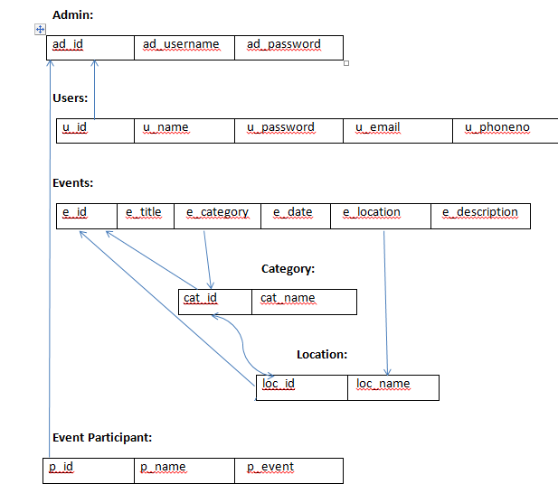

**Figure 29: Relational Mapping**